Supplementary material

Supplementary Table 1. CADCR agreement and its impact on clinical decision by abnormal findings.
Findings | Agreement with CADCR, mean (SD) | CADCR impact on clinical decision, mean (SD)
Cardiomegaly | 5.3 (1.0) | 3.7 (1.4)
Consolidation | 5.0 (1.0) | 3.6 (1.3)
Fibrosis | 4.4 (1.1) | 2.9 (1.3)
Calcification | 4.5 (1.3) | 2.7 (1.2)
Nodule | 4.5 (1.3) | 3.0 (1.1)
Pleural effusion | 5.5 (0.5) | 4.1 (1.5)
Pneumoperitoneum | 5.4 (0.7) | 4.5 (1.8)
Pneumothorax | 5.5 (0.8) | 4.7 (1.8)
Atelectasis | 4.3 (1.0) | 3.3 (1.3)
CADCR computer aided detection on chest radiograph.
Range 1–7, 7: strongly agree. SD, standard deviation.

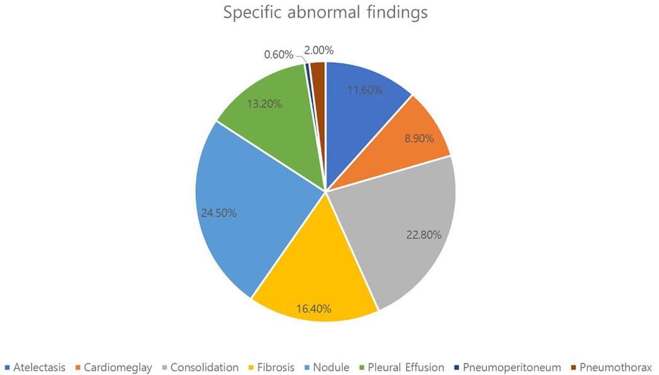
Supplementary Fig. 1. The proportion of abnormal findings interpreted by computer aided detection system.

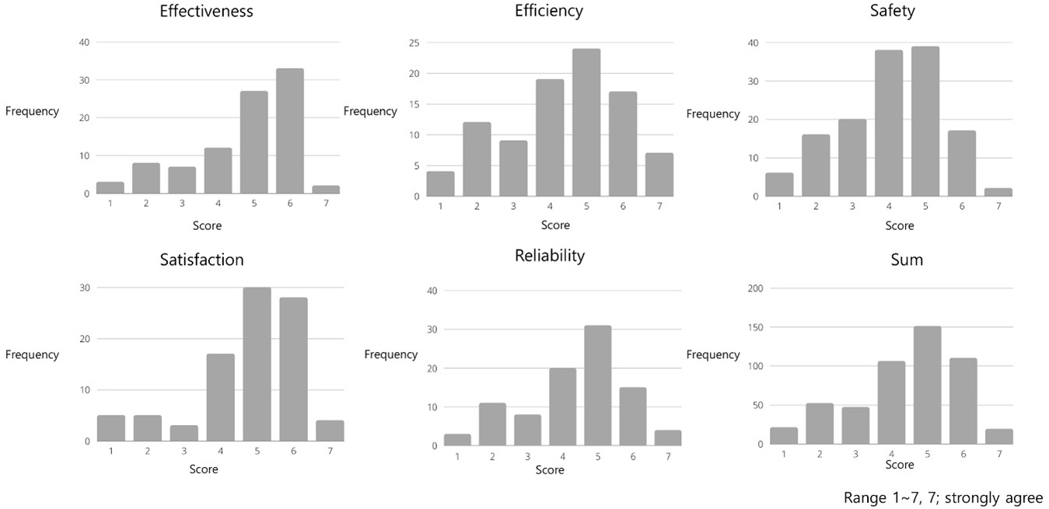
Supplementary Fig. 2. Response distribution of user experience with computer aided detection system on chest radiograph.

Supplementary Fig. 3. Average scores of user experience by physicians experience.

